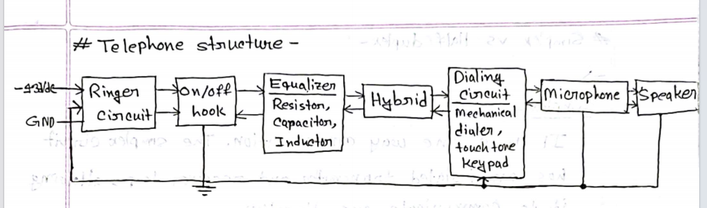
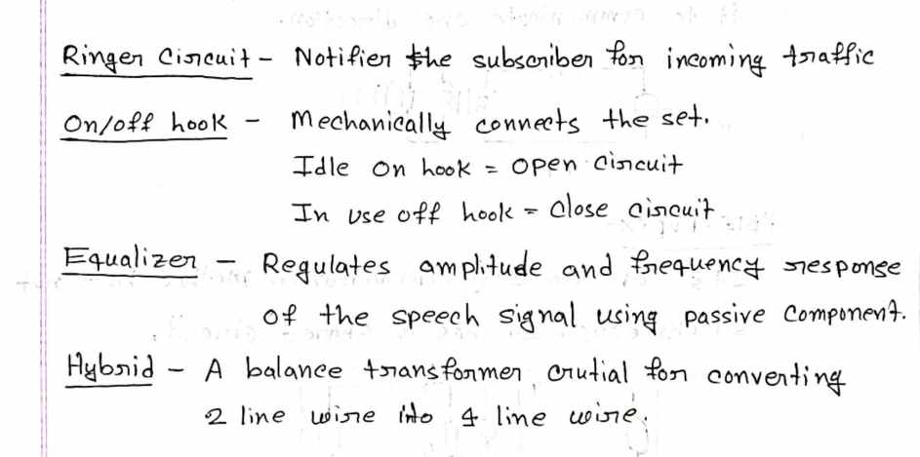
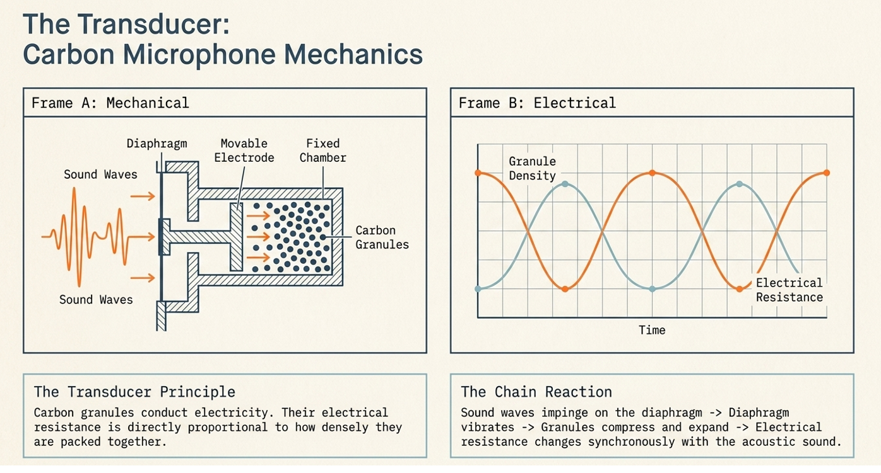

Definition
A carbon microphone is a transducer that converts sound energy into electrical signals using carbon granules.

Working Principle
- Sound waves hit the diaphragm.
- The diaphragm vibrates.
- The movable electrode compresses and releases the carbon granules.
- The density of the carbon granules changes.
- As density changes, electrical resistance changes.
- This produces a changing electrical current that carries the voice signal.

Chain Reaction (Slide Based)
Sound Waves → Diaphragm Vibrates → Carbon Granules Compress/Expand → Resistance Changes → Electrical Signal Produced

3. Why is a Small Amount of Sidetone Necessary? (5 Marks)

Definition
Sidetone is hearing a small part of your own voice in the receiver while talking.

Why is it Necessary?
- It lets the caller know the phone is working.
- It helps maintain a natural speaking level.
- Without sidetone, people tend to shout.
- Too much sidetone makes people speak too softly.
- Therefore, a balanced (small) amount of sidetone gives the best communication.

4. Low & High Sidetone (Anti-Sidetone Circuit) (5 Marks)

Low Sidetone (Transmitting)
When we speak,
- Current in L1 and L2 flows in opposite directions.
- Magnetic fields cancel each other.
- Very little current is induced in L3 (Receiver).
- We hear only a small amount of our own voice.

High Sidetone (Receiving)
When another person speaks,
- Current in L1 and L2 flows in the same direction.
- Magnetic fields add together.
- Strong current is induced in L3.
- Incoming voice is heard clearly.

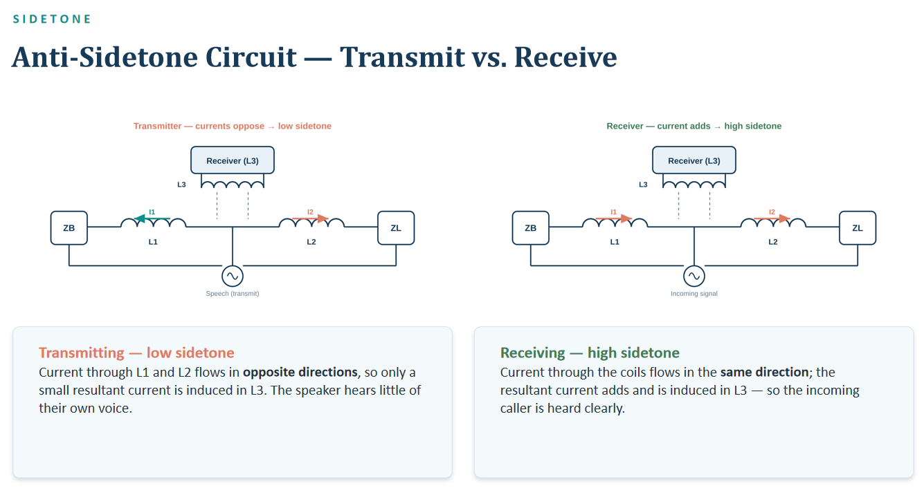

Sidetone
Definition:
Sidetone is the speaker's own voice heard in the receiver (earpiece) while talking.

Echo
Definition:
Echo is the reflected voice that returns to the speaker due to impedance mismatch in the transmission path
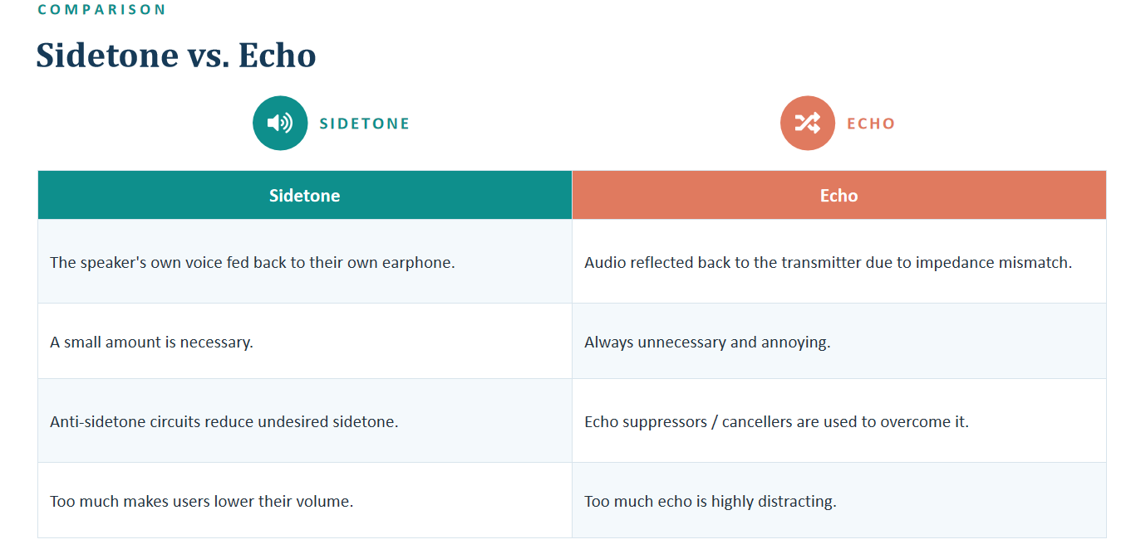

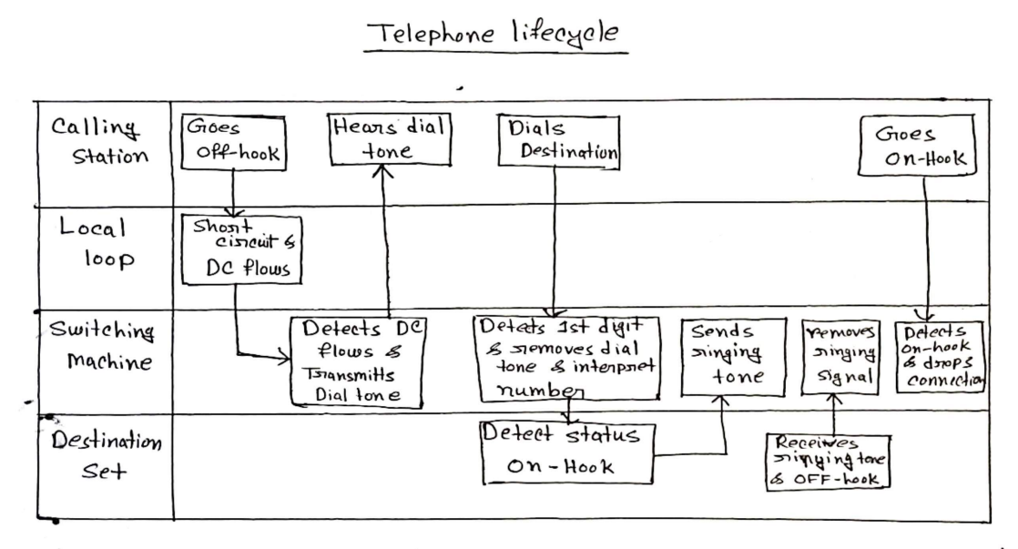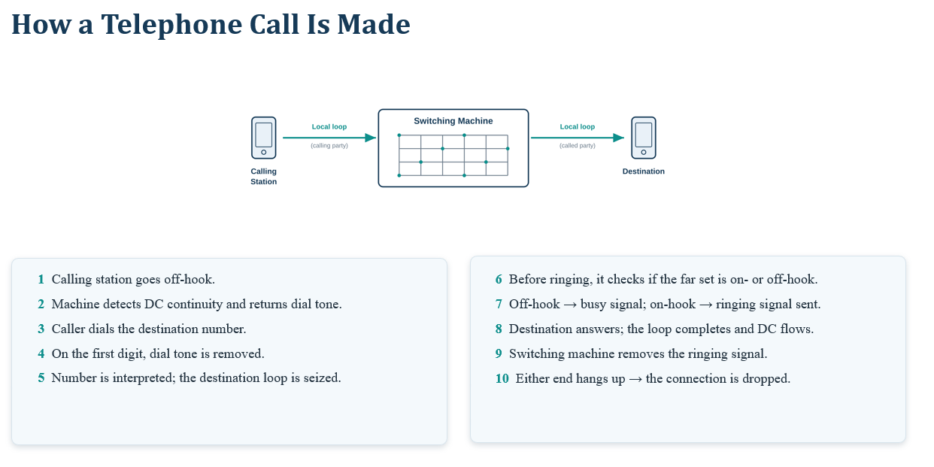
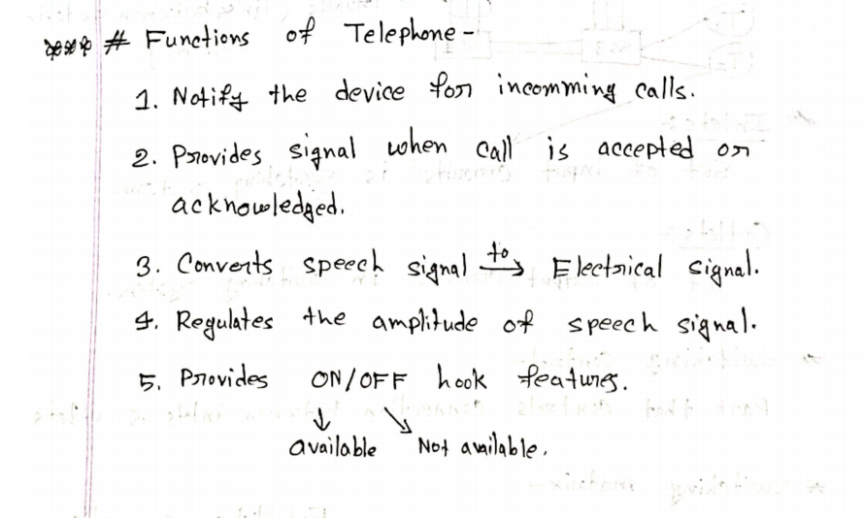
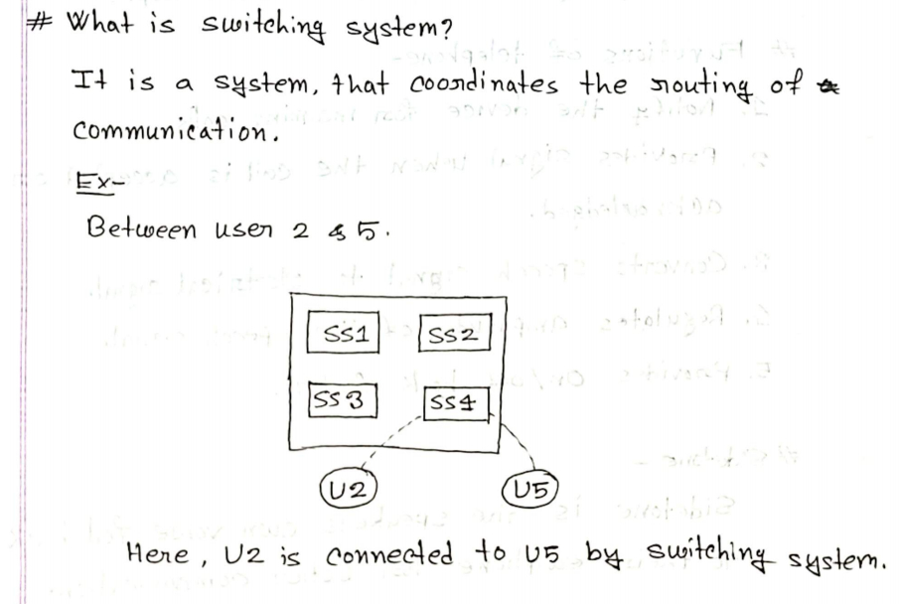

Why is a Switching System Important? (5 Marks)
- Establishes Connection – Connects the caller with the receiver.
- Routes Calls – Selects the correct path for the call.
- Efficient Resource Use – Shares network resources efficiently.
- Supports Many Calls – Allows many users to communicate at the same time.
- Disconnects Calls – Releases the connection after the call ends so it can be used again.
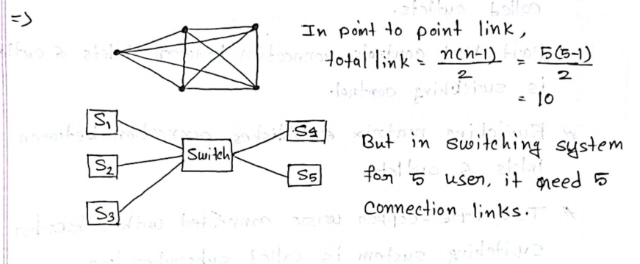

Caller ID (Easy 2–3 Marks)
Definition:
Caller ID (CID) is a telephone service that shows the caller's information (name and/or phone number) on the receiver's phone before it rings.
Easy Definition:
Caller ID is a service that displays the caller's phone number or name before the phone rings.

How Caller ID Works (Easy 5 Marks)
- The exchange detects an incoming call.
- It collects the caller's information (name/number).
- The information is sent using FSK (Frequency Shift Keying).
- The receiver's phone decodes the data.
- The phone displays the caller's details before ringing.
